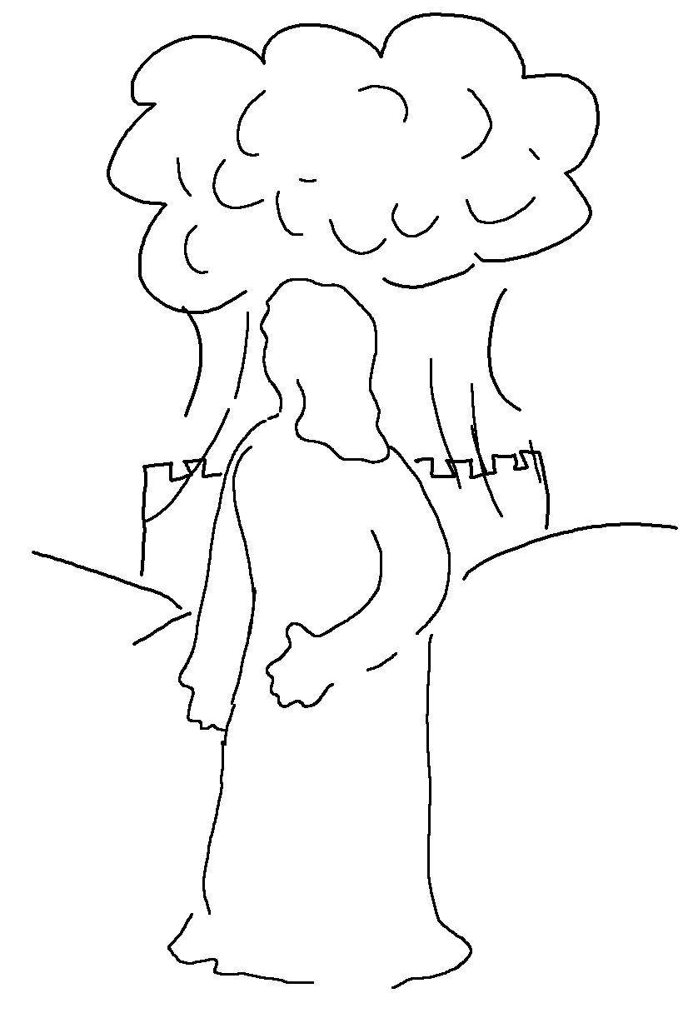
The eyes of the _ _ _ _ watch over those who do right, and his ears are open to their _ _ _ _ _ _ _. 1 Peter 3:12_{NLT}

